AI LAB EXP – 4

**IMPLEMENTATION AND ANALYSIS OF DFS AND BFS FOR AN APPLICATION**

**Tejas Ashok**

**RA1911030010090**

**AIM**

Given the start node of a graph, display the traversal of the graph using depth first and then breadth first search.

**DFS**

**Algorithm**

1. SET STATUS = 1 (ready state) for each node in G
2. Push the starting node A on the stack and set its STATUS = 2 (waiting state)
3. Repeat Steps 4 and 5 until STACK is empty
4. Pop the top node N. Process it and set its STATUS = 3 (processed state)
5. Push on the stack all the neighbours of N that are in the ready state (whose STATUS = 1) and set their  
   STATUS = 2 (waiting state)  
   [END OF LOOP]
6. EXIT

**Code**

class graph:

def __init__(self):

self.graph = {}

def addNode(self, key, val):

if key not in self.graph:

self.graph[key] = [val]

else:

self.graph[key].append(val)

def DFSUtil(self, v, visited):

visited.add(v)

print(v, end=" ")

for neighbour in self.graph[v]:

if neighbour not in visited:

self.DFSUtil(neighbour, visited)

def DFS(self, vertex):

visited = set()

self.DFSUtil(vertex, visited)

g = graph()

g.addNode(1, 2)

g.addNode(1, 4)

g.addNode(1, 3)

g.addNode(2, 5)

g.addNode(2, 4)

g.addNode(3, 6)

g.addNode(4, 3)

g.addNode(4, 6)

g.addNode(4, 7)

g.addNode(5, 4)

g.addNode(5, 7)

g.addNode(6, 6)

g.addNode(7, 6)

vert = int(input("Start from vertex: "))

print("Following is Depth First Traversal from Vertex {}:".format(vert))

g.DFS(vert)

print()

**Output**

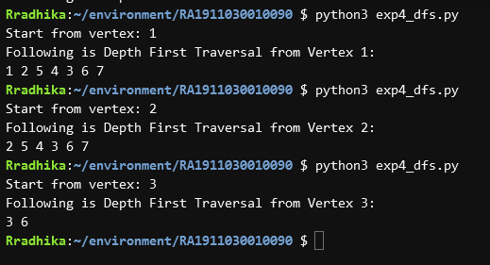

**BFS**

**Algorithm**

1. SET STATUS = 1 (ready state) for each node in G
2. Enqueue the starting node A and set its STATUS = 2 (waiting state)
3. Repeat Steps 4 and 5 until QUEUE is empty
4. Dequeue a node N. Process it and set its STATUS = 3 (processed state).
5. Enqueue all the neighbours of N that are in the ready state (whose STATUS = 1) and set their STATUS = 2  
   (waiting state)  
   [END OF LOOP]
6. EXIT

**Code**

class graph:

def __init__(self):

self.graph = {}

def addNode(self, key, val):

if key not in self.graph:

self.graph[key] = [val]

else:

self.graph[key].append(val)

def BFS(self, x):

visited = [False] * (max(self.graph) + 1)

queue = []

queue.append(x)

visited[x] = True

while queue:

x = queue.pop(0)

print(x, end=" ")

for i in self.graph[x]:

if visited[i] == False:

queue.append(i)

visited[i] = True

g = graph()

g.addNode(1, 2)

g.addNode(1, 4)

g.addNode(1, 3)

g.addNode(2, 5)

g.addNode(2, 4)

g.addNode(3, 6)

g.addNode(4, 3)

g.addNode(4, 6)

g.addNode(4, 7)

g.addNode(5, 4)

g.addNode(5, 7)

g.addNode(6, 6)

g.addNode(7, 6)

vert = int(input("Start from vertex: "))

print("Following is Breadth First Traversal from Vertex {}:".format(vert))

g.BFS(vert)

print()

**Output**

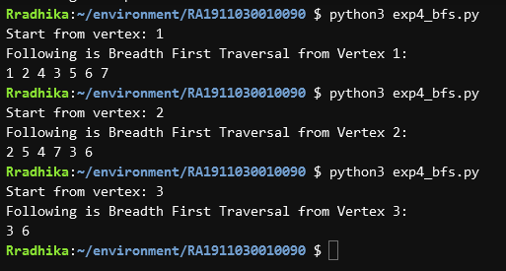

**RESULT**

Successfully traversed through the graph using BFS and DFS.